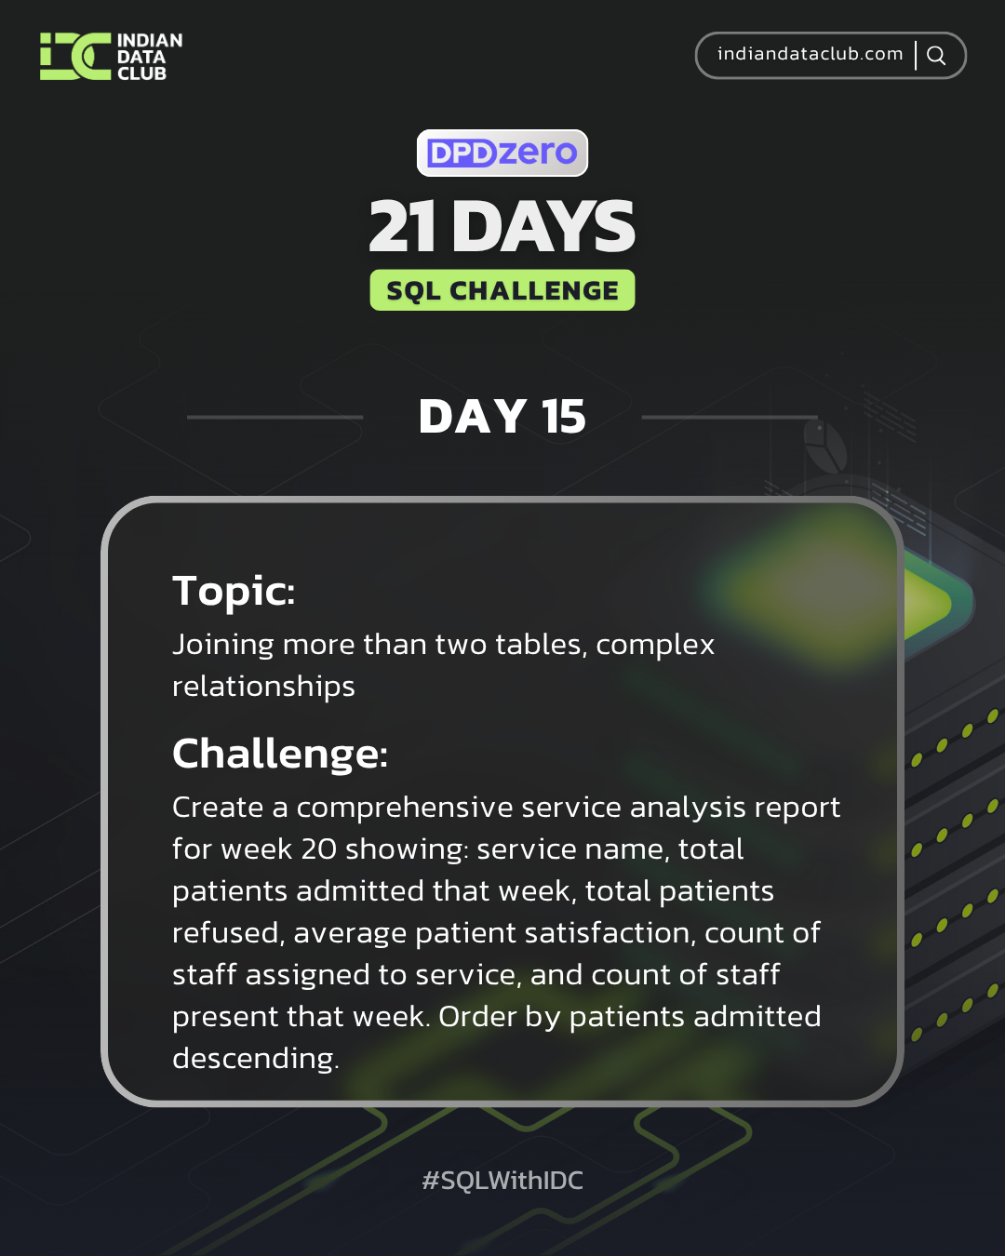

Day-15 SQL Challenge
Day-15 Challenge:
Create a comprehensive service analysis report for week 20 showing: service name, total patients admitted that week, total patients refused, average patient satisfaction, count of staff assigned to service, and count of staff present that week. Order by patients admitted descending.
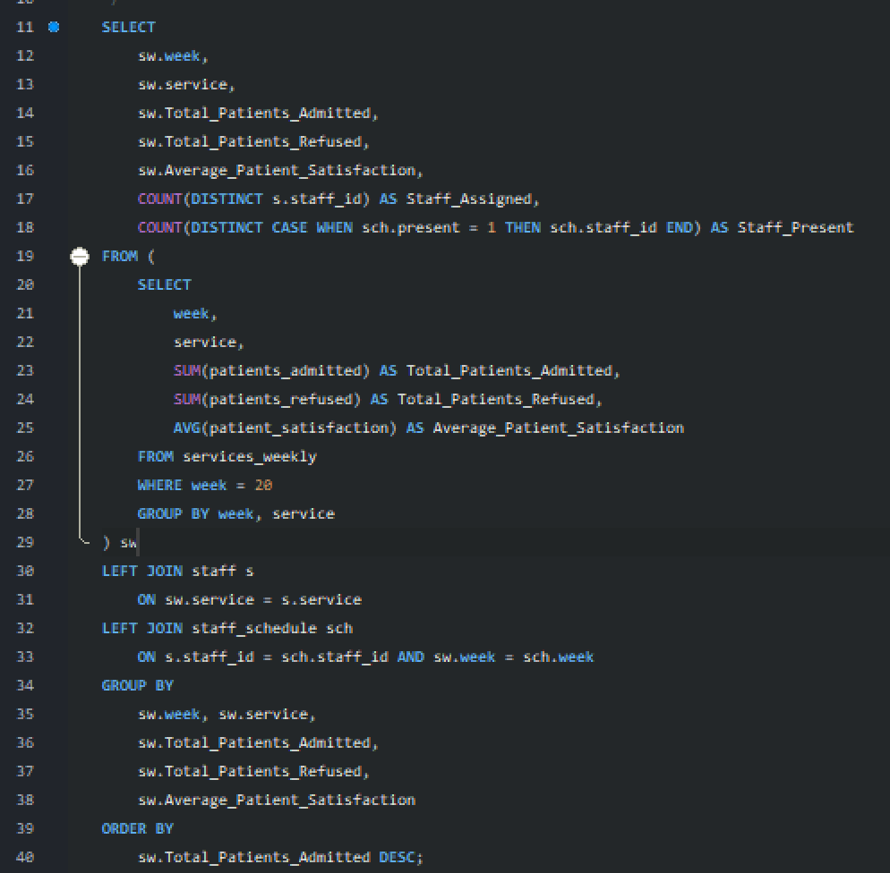
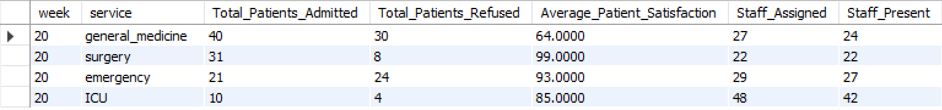

Practice Questions:
1. Join patients, staff, and staff_schedule to show patient service and staff availability.
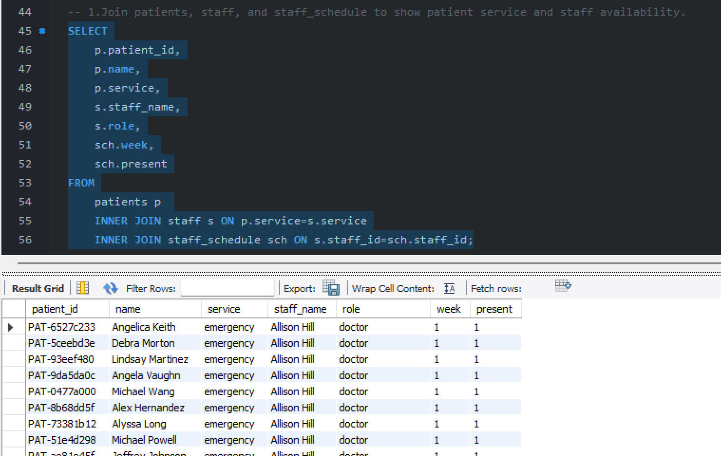

2. Combine services_weekly with staff and staff_schedule for comprehensive service analysis.
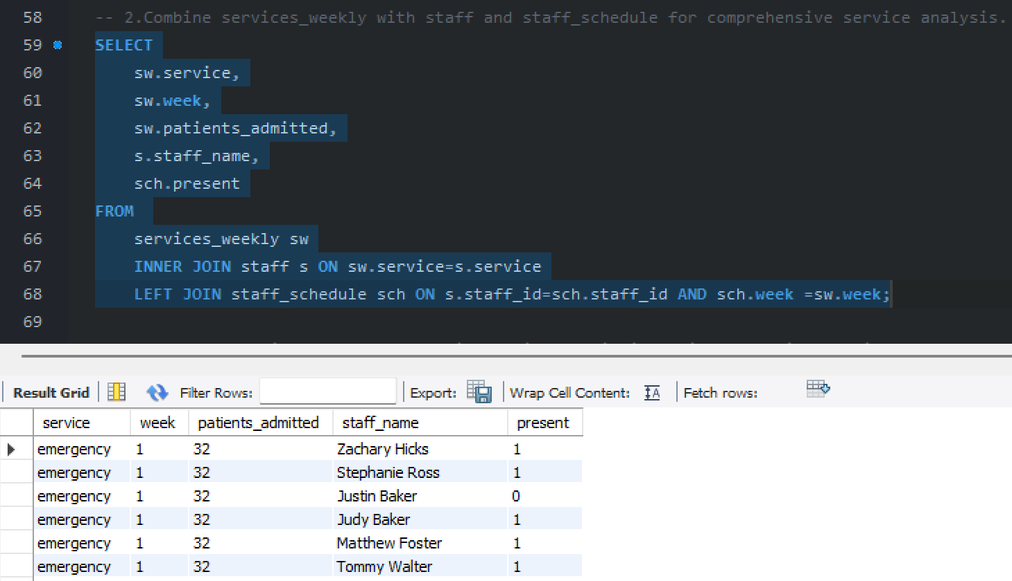

3. Create a multi-table report showing patient admissions with staff information.
